Business Analytics
Multi-Echelon Supply Chain Network Design via Mixed-Integer Linear Programming (MILP)
Optimizing Factory → Warehouse → Customer Zone Flows to Minimize Total Operating Expenditure
Prepared for: BA – Business Analytics Coursework
Model built and solved using Python (PuLP / CBC Solver)

Table of Contents

1. Executive Summary
This report designs and solves a Mixed-Integer Linear Programming (MILP) model for a two-echelon distribution network consisting of 3 factories, 4 candidate warehouse locations, and 6 customer demand zones. The model jointly decides (a) which warehouses to open, (b) how much product to ship on each factory–warehouse and warehouse–customer lane, subject to production capacity, warehouse throughput capacity, lane transport limits, and minimum customer service-level requirements.
The optimal solution opens 2 of the 4 candidate warehouses (W2 and W3), achieving a minimum total operating expenditure of $22,357.00 while meeting the required 95% minimum service level for every customer zone. Full formulation, input data, solved flows, and managerial recommendations follow.

2. Problem Description & Network Structure
The supply chain is modeled as a directed, capacitated, two-echelon network:
- Echelon 1 (Production → Distribution): 3 factories (F1–F3) each with a fixed production capacity ship finished goods to a subset of 4 candidate warehouses (W1–W4).
- Echelon 2 (Distribution → Consumption): Each open warehouse ships product onward to 6 customer demand zones (C1–C6), each with a fixed demand and a minimum service-level requirement.
- Warehouses are not automatically available — each carries a fixed cost to open and a finite throughput capacity, making the warehouse-opening decision a discrete (binary) choice nested inside a continuous flow-optimization problem. This combination of binary facility-location variables and continuous flow variables is exactly what makes the problem a Mixed-Integer (rather than pure) Linear Program.
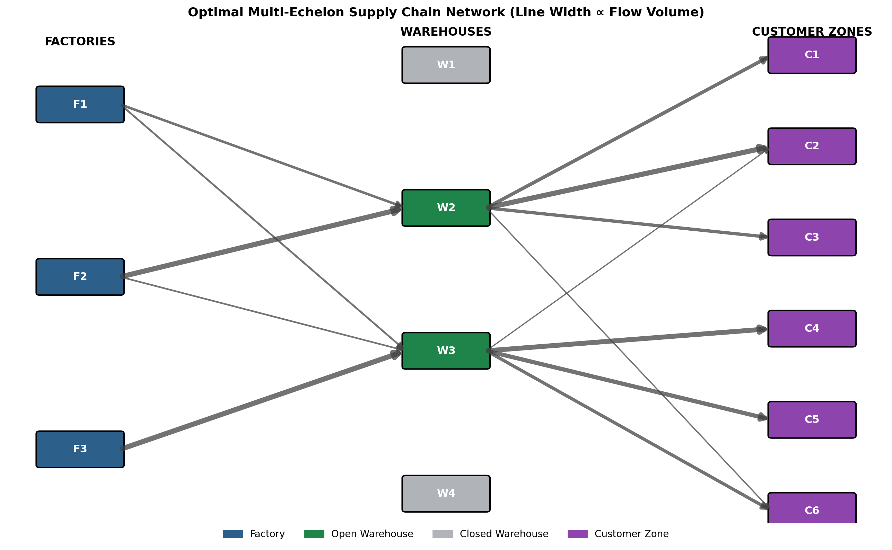

3. Formal MILP Formulation

3.1 Sets
- I = {F1, F2, F3} — set of factories, indexed by i
- J = {W1, W2, W3, W4} — set of candidate warehouse locations, indexed by j
- K = {C1, C2, ..., C6} — set of customer zones, indexed by k

3.2 Parameters
- Capᵢ — production capacity of factory i
- Demₖ — demand of customer zone k
- Thrⱼ — maximum throughput capacity of warehouse j if opened
- FCⱼ — fixed cost of opening warehouse j
- VCⱼ — variable per-unit handling cost at warehouse j
- c¹ᵢⱼ — per-unit transport cost from factory i to warehouse j
- c²ⱼₖ — per-unit transport cost from warehouse j to customer k
- L¹ᵢⱼ — maximum lane (arc) capacity, factory i → warehouse j
- L²ⱼₖ — maximum lane (arc) capacity, warehouse j → customer k
- αₖ — minimum required service level (fraction of demand that must be fulfilled) for customer k

3.3 Decision Variables
- xᵢⱼ ≥ 0 — continuous: units shipped from factory i to warehouse j
- yⱼₖ ≥ 0 — continuous: units shipped from warehouse j to customer k
- zⱼ ∈ {0,1} — binary: 1 if warehouse j is opened, 0 otherwise

3.4 Objective Function
Minimize total supply chain operating expenditure — the sum of upstream transport cost, downstream transport cost, warehouse variable handling cost, and warehouse fixed opening cost:
Min Z = Σᵢ Σⱼ (c¹ᵢⱼ · xᵢⱼ) + Σⱼ Σₖ (c²ⱼₖ · yⱼₖ) + Σⱼ ( VCⱼ · Σₖ yⱼₖ ) + Σⱼ (FCⱼ · zⱼ)

3.5 Constraints (Constraint Matrix)
(C1) Factory production capacity — total outbound shipments from a factory cannot exceed its capacity:
Σⱼ xᵢⱼ ≤ Capᵢ ∀ i ∈ I
(C2) Warehouse flow conservation — inbound flow to a warehouse equals its outbound flow (no accumulation):
Σᵢ xᵢⱼ = Σₖ yⱼₖ ∀ j ∈ J
(C3) Warehouse storage / throughput capacity, linked to the open/close decision — a closed warehouse (zⱼ = 0) can ship nothing:
Σₖ yⱼₖ ≤ Thrⱼ · zⱼ ∀ j ∈ J
(C4) Minimum service level — each customer zone must receive at least αₖ of its demand:
Σⱼ yⱼₖ ≥ αₖ · Demₖ ∀ k ∈ K
(C5) Demand ceiling — shipments cannot exceed actual demand (no overproduction to a zone):
Σⱼ yⱼₖ ≤ Demₖ ∀ k ∈ K
(C6) Multi-echelon transport (lane) limits — maximum volume per individual transport lane in each echelon:
xᵢⱼ ≤ L¹ᵢⱼ ∀ i,j yⱼₖ ≤ L²ⱼₖ ∀ j,k
(C7) Variable domains:
xᵢⱼ ≥ 0, yⱼₖ ≥ 0 (continuous) zⱼ ∈ {0,1} (binary)

4. Case Study Instance Data

4.1 Factory Capacities
Factory | Production Capacity (units)
F1 | 800
F2 | 600
F3 | 700

4.2 Warehouse Parameters
Warehouse | Throughput Cap. | Fixed Open Cost ($) | Variable Handling Cost ($/unit)
W1 | 900 | 5,000 | 1.20
W2 | 700 | 4,000 | 1.00
W3 | 1000 | 6,000 | 1.50
W4 | 600 | 3,500 | 0.80

4.3 Customer Zone Demand (Min. Service Level = 95%)
Customer Zone | Demand (units) | Min. Required Fulfillment (units)
C1 | 200 | 190
C2 | 350 | 332.5
C3 | 180 | 171
C4 | 300 | 285
C5 | 250 | 237.5
C6 | 220 | 209

4.4 Transport Cost Matrix — Factory → Warehouse ($/unit)
Factory \ WH | W1 | W2 | W3 | W4
F1 | 4.50 | 6.00 | 8.50 | 7.00
F2 | 5.50 | 3.50 | 6.50 | 9.00
F3 | 7.50 | 6.50 | 3.00 | 5.00

4.5 Transport Cost Matrix — Warehouse → Customer ($/unit)
WH \ Customer | C1 | C2 | C3 | C4 | C5 | C6
W1 | 2.00 | 3.50 | 5.00 | 6.50 | 8.00 | 7.00
W2 | 4.00 | 2.00 | 3.00 | 5.50 | 7.50 | 6.00
W3 | 7.00 | 6.00 | 4.50 | 2.50 | 3.00 | 4.00
W4 | 6.50 | 5.00 | 6.00 | 4.00 | 2.00 | 3.50

5. Optimal Solution Results

5.1 Solver Summary
- Solver: CBC (Coin-or Branch and Cut) via PuLP
- Status: Optimal
- Total Optimal Operating Expenditure: $22,357.00

5.2 Warehouse Open/Close Decisions
Warehouse | Decision | Throughput Capacity
W1 | CLOSED | 900
W2 | OPEN | 700
W3 | OPEN | 1000
W4 | CLOSED | 600
The model chooses to open W2 and W3 — the two warehouses with the lowest combined fixed and variable handling costs relative to their geographic position — and to leave W1 and W4 unopened, avoiding their fixed costs entirely despite W1's competitive downstream transport rates to C1.

5.3 Optimal Factory → Warehouse Flows
Lane | Volume (units) | Unit Cost ($)
F1 → W2 | 200.0 | 6.00
F1 → W3 | 125.0 | 8.50
F2 → W2 | 500.0 | 3.50
F2 → W3 | 100.0 | 6.50
F3 → W3 | 500.0 | 3.00

5.4 Optimal Warehouse → Customer Flows
Lane | Volume (units) | Unit Cost ($)
W2 → C1 | 190.0 | 4.00
W2 → C2 | 300.0 | 2.00
W2 → C3 | 171.0 | 3.00
W2 → C6 | 39.0 | 6.00
W3 → C2 | 32.5 | 6.00
W3 → C4 | 285.0 | 2.50
W3 → C5 | 237.5 | 3.00
W3 → C6 | 170.0 | 4.00

5.5 Customer Demand Fulfillment
Customer | Demand | Served | % Fulfilled
C1 | 200 | 190.0 | 95.0%
C2 | 350 | 332.5 | 95.0%
C3 | 180 | 171.0 | 95.0%
C4 | 300 | 285.0 | 95.0%
C5 | 250 | 237.5 | 95.0%
C6 | 220 | 209.0 | 95.0%

5.6 Factory Capacity Utilization
Factory | Capacity | Used | % Utilized
F1 | 800 | 325.0 | 40.6%
F2 | 600 | 600.0 | 100.0%
F3 | 700 | 500.0 | 71.4%

5.7 Cost Breakdown
Cost Component | Amount ($) | % of Total
Factory → Warehouse transport | 6,162.50 | 27.6%
Warehouse → Customer transport | 4,407.00 | 19.7%
Warehouse variable handling | 1,787.50 | 8.0%
Warehouse fixed opening cost | 10,000.00 | 44.7%
TOTAL | 22,357.00 | 100.0%

6. Managerial Insights & Recommendations
- Fixed warehouse-opening costs dominate the cost structure (44.7% of total spend), confirming that facility-location decisions — not transport routing — are the primary lever for cost reduction in this network.
- F2 operates at 100% capacity utilization and is the cheapest source into the network's busiest hub (W2); expanding F2's capacity should be evaluated first if demand grows, ahead of adding new factory capacity elsewhere.
- All customer zones are served at exactly the 95% minimum service level, meaning the service-level constraint is binding everywhere — raising the required service level (e.g., to 100%) will increase total cost and should be tested as a sensitivity scenario before being adopted as policy.
- W1 and W4 remain closed under current demand; however, W1 offers the cheapest lane to C1 ($2.00/unit). If C1's demand or service-level target rises substantially, or if F1’s output must be re-routed, re-opening W1 should be re-evaluated.
- Recommended next steps: (1) run sensitivity analysis on fixed opening costs and service levels, (2) test multi-period demand seasonality, and (3) extend the model with single-sourcing or lead-time constraints if required by operations.

7. Appendix — Implementation Note
The MILP was implemented in Python using the PuLP modeling library and solved with the open-source CBC branch-and-cut solver. The full model script (sets, parameters, decision variables, objective, and all constraints C1–C7) is provided as a companion file, model.py, alongside this report.

